THE MANUFACTURING OF PAPER

Abstract

Papermaking is an industry which both engineering and chemistry play important parts. The functions of the engineer and chemist are generally regarded as independent of one another, so that the chemist is only called in by the engineer when efforts along the lines of mechanical improvement have failed, and vice versa. It is impossible, however, to draw a hard and fast line, and the best results in the art of papermaking are only possible when the manufacturer appreciates the fact that the skill of both is essential to progress and commercial success.

<https://www.gutenberg.org/files/46449/46449-h/46449-h.htm>

https://www.bls.gov/iag/tgs/iag322.htm#prices

By R.W. Sindall, F.C.S.

# SPECIAL KINDS OF PAPER

There are many varieties of paper products obtained by submitting finished paper to a few special processes. Of these only a few of the more important will be described.

These products can be divided approximately into three classes:

* Papers coated on one side or both sides with various substances, such as “art,” photographic papers, etc.
* Papers impregnated with chemicals, such as blueprint, medicated, and cheque papers.
* Paper pulp converted into modified products by chemical treatment, such as vulcanized board, viscoid, etc.

Of the first class, the coated papers used for art and chromo illustrations are the most important.

Of the second class, the blueprints and papers impregnated with chemicals, chiefly employed to produce engineers' drawings, may be regarded as typical.

In the third class, vegetable parchment and vulcanized board are the most familiar.

**Parchment Paper***.* This is produced by the action of sulfuric acid upon ordinary paper, the most suitable for this purpose being made from unsized cotton rag, free from such additions as mechanical wood pulp (Ryder, 1964). The presence of the latter substance should be avoided, as it is liable to char or burn, so that in the finished product it shows itself in the form of small holes. [The process depends upon the power of sulfuric acid to change the surface of the paper into a gelatinous mass, which has been shown to consist of a substance called amyloid.

The best parchment is made from pure cellulose such as rag or chemical wood pulp. The quality of the parchment depends upon attention to the strength of the acid, the temperature of the acid bath, the period of immersion, the complete removal of the acid, and the careful drying of the wet parchment.

The acid is employed at a strength of 1·71 specific gravity, being prepared by diluting the commercial concentrated acid in a leaden vessel, with enough water.

The parchment is generally prepared by passing a continuous sheet of paper through a bath of acid of the proper strength at a speed which ensures the correct period of immersion. As the treated paper leaves the bath it passes through squeezing rolls which remove the excess of acid, and the paper is then led through a series of tanks containing fresh water, the last traces of acid being neutralized by small additions of ammonia, or some alkali, to the last washing tank. The wet parchment is then passed through suitable rollers and carefully dried over cylinders heated internally by steam. The paper is kept perfectly stretched as it dries, because it shrinks enormously, and would otherwise become cockled and uneven (Mayer, 1860).

Thick sheets of parchment paper are frequently made by passing three sheets of paper through the acid bath and bringing them together between the rollers before washing. The sheets unite when pressed together; the remainder of the process being the same as that employed for single sheets.

The parchment exhibits remarkable differences to the original paper, the strength being increased three or four times, the density about 30 per cent., the latter being shown by the shrinkage, which amounts to at least 30 per cent.

**Vulcanized Paper***.* Zinc chloride has the property of parchmentizing paper in a manner like sulfuric acid. The product obtained when this reagent is used is generally termed vulcanized fiber. The paper is passed as a continuous sheet into a bath of strong zinc chloride, having a density of 160-170 Twaddell, which causes the cellulose to swell up and partly gelatinize. A very large excess of strong zinc chloride is necessary, and the process is only rendered commercially possible by careful recovery of the zinc from the washing waters, which are submitted to chemical treatment.

The vulcanized product is subsequently treated with nitric acid or with a mixture of nitric and sulfuric acids to render them waterproof. Dextrin is frequently employed to retard the chemical action to permit of the necessary manipulation of the material before it is finally washed. The complete removal of the excess of zinc and acid is a necessary feature of the whole operation.

**Willesden Paper**. When paper is passed through an ammoniacal solution of copper oxide, a superficial gelatinization of the surface takes place, so that the paper when washed and dried is impregnated with copper oxide, which helps to preserve it, and it becomes waterproof (Bertrams, Ltd., 1892). Such material is well known as Willesden paper.

**Blueprint or Cyanotype Papers***.* This name is usually given to the process by means of which blueprints of engineers' and architects' plans can be reproduced. It was discovered in 1842 by Sir John Herschel. It is a useful method of reproducing drawings, and incidentally is of great value to the amateur photographer because of the facility with which it can be applied for getting proofs from negatives quickly and easily without special baths and chemicals. The process is based upon the reduction of a ferric salt to the ferrous condition by light, and the formation of Prussian blue by the action of potassium ferricyanide. The negative cyanotype gives white lines on a blue ground. Various formulas are in common use.

|  |  |  |  |  |
| --- | --- | --- | --- | --- |
|  | | | | |
| — | Herschel. | Clark. | Watt. | Rockwood. |
|  | | | | |
| Solution 1. |  |  |  |  |
| Potassium ferricyanide | 16 | 27 | 48 | 10 |
| Water | 100 | 100 | 100 | 100 |
| Ammonia | — | 2·3 | — | — |
| Saturated solution of oxalic acid | — | 20 | — | — |
|  | | | | |
| Solution 2. |  |  |  |  |
| Ammonia-citrate of iron | 20 | 30 | 50 | 30 |
| Water | 100 | 100 | 100 | 100 |
| Boric acid | — | — | 0·5 | — |
| Dextrin | — | — | — | 5 |
|  | | | | |

Equal parts of the two prepared solutions are mixed when required and spread evenly over well-sized paper. The paper is hung up, dried, and preserved in a dark dry place.

The *positive cyanotype* gives blue lines on a white ground, being the reverse of the ordinary blueprint. That is, no image is formed where the light acts, and the reaction is the formation of blue due to the union of a ferrous salt with ferrocyanide of potassium (Veitch, 1907). Pizzighelli in 1881 gave the following formula:

|  |  |  |  |  |
| --- | --- | --- | --- | --- |
|  | | | | |
| — | Solution 1. | Solution 2. | Solution 3. | Solution 4. |
|  | | | | |
| Water | 100 | 100 | 100 | 100 |
| Gum Arabic | 20 | — | — | — |
| Ammonia-citrate of iron | — | 50 | — | — |
| Ferric chloride | — | — | 50 | — |
| Potassium ferrocyanide | — | — | — | 20 |
|  | | | | |

Mix the first three solutions in the following order in the proportions stated:

|  |  |  |
| --- | --- | --- |
| Solution 1. | 20 | Parts. |
| Solution 2. | 8 | Parts. |
| Solution 3. | 5 | Parts. |

As soon as the solution, which at first gets thick and cloudy, is clear and thin, it is spread over the surface of well-sized paper, which is then dried in a warm room.

The print, which appears yellow on a dark yellow ground, is treated with the developer (solution 4) by means of a brush dipped in the solution. When the image is deep blue in color, the print is washed in water and then placed in dilute hydrochloric acid (1 part of acid to 10 parts of water) till the ground is quite white (Herring, 1860). A final washing with water is then necessary. Waterhouse gives the following formula:

|  |  |  |  |  |
| --- | --- | --- | --- | --- |
|  | | | | |
| — | Solution 1. | Solution 2. | Solution 3. | Solution 4. |
|  | | | | |
| Water | 650 | 150 | — | 100 |
| Gum Arabic | 170 | — | — | — |
| Tartaric acid | — | 40 | — | — |
| Ferric chloride solution 45° Baumé | — | — | 150 | — |
| Ferrocyanide of potassium | — | — | — | 20 |
|  | | | | |

Solutions 1 and 2 are mixed and No. 3 added gradually with constant stirring. The mixture is left twenty-four hours and diluted with water to a specific gravity of 1·100.

The paper is coated with the solution and used as already directed, being developed in ferrocyanide of potassium solution and washed with water, treated with weak hydrochloric acid, and then finally cleaned from all traces of acid.

**Black Lines on a White Ground.** This modification of the ordinary blueprint is arrived at with the following formula:

|  |  |  |
| --- | --- | --- |
| Water | 96·0 | Parts. |
| Gelatin | 1·5 | Parts. |
| Perchloride of iron (in syrupy condition) | 6·0 | Parts. |
| Tartaric acid | 6·0 | Parts. |
| Sulphate of iron | 1·5 | Parts. |

The paper is coated with the solution. After printing, the image is developed with a solution containing the following:

|  |  |  |
| --- | --- | --- |
| Gallic acid | 1 | Part. |
| Alcohol | 10 | Parts. |
| Water | 50 | Parts. |

A final washing of the print with water completes the operation.

## Coated Papers.

This term should properly include all the varieties of special papers which are coated with extraneous matter for particular purposes, such as art, chromo, tinfoil, gilt, emery, carbon, photographic, marble, and sandpapers. In practice however, the term is almost entirely limited to “art” papers used for illustration work and half-tone printing.

An “art” paper, using the definition given above, consists of an ordinary sheet of paper, one or both sides of which have been coated by the application of a mixture of a mineral matter, such as China clay or satin white, and some adhesive, like casein or glue (Onfroy, 1906). The object of the coating is to impart to the paper a perfectly smooth surface, rendered necessary because of the conditions under which the printing of the illustrations is carried out.

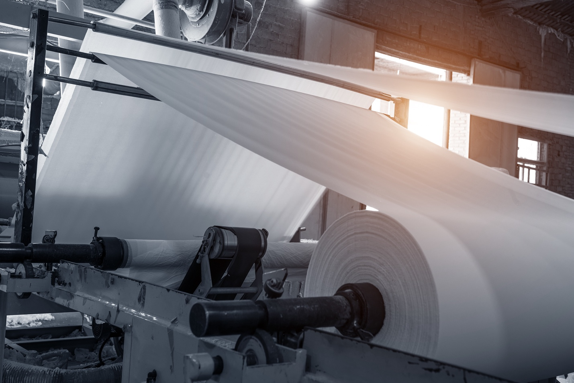

Paper and pulp manufacturing mill.

The machine used for coating the paper consists of a large hollow drum about 40 inches diameter and 48 inches wide. The paper is brought over upon the drum in a continuous sheet, and the coating mixture applied to the surface by means of a revolving brush or an endless felt which rotates in a copper trough containing a coating mixture which is usually maintained at a temperature of 120° Fahrenheit.

The amount of material put on to the surface of the paper is varied by altering the proportion of water in the trough (Andés, 1907). As the wet coated paper is drawn over the drum it comes into contact with a number of flat brushes which move from side to side and brush the coating well into the paper.

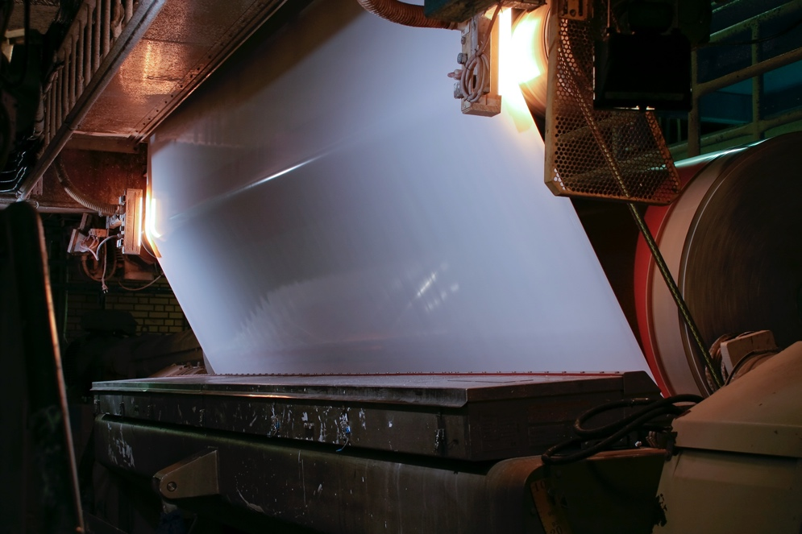

Coating paper in paper mill.

The last two or three brushes on the drum are made of very fine bristles, so that when the coated paper leaves the machine the surface is perfectly even and free from brush marks. The wet paper is then drawn up an inclined ladder by an ingenious device, which causes the paper to fall into festoons or loops, and these are carried bodily forward by means of travelling chains. The process, somewhat difficult to describe, is more easily understood by a study of the illustrations given.

The paper is dried by a current of warm air which can be obtained by means of steam pipes placed below the festoons or with a special air blower. The dry paper is then led through guide rolls and wound up in the form of a reel.

The paper at this stage has a dull coated surface, which is somewhat rough and unfinished, and a high polish is imparted to it by a machine known as a supercalender (Sindall, 1906).

The supercalender consists of a number of alternate steel and cotton, or paper rolls placed vertically in a stack one above the other. When the coated paper is led through this machine the friction of the alternate steel and cotton rolls produces a high finish on its surface.

An art paper coated on both sides is manufactured by passing the paper through the coating machine twice. Machines have been devised for coating both sides of the paper at one operation, but these are not in very general use.

Tinted art papers are prepared in the same manner, the desired color being obtained by the addition of pigments or aniline dyes to the mixture in the trough containing the coating materials. When the two sides of such tinted papers are colored differently, they are often described as duplex coated papers.

**Imitation Art Papers** are prepared by quite a different process, although they have the appearance of the coated paper. They are merely esparto papers very heavily loaded, containing frequently as much as 25 to 30 per cent. of mineral matter prepared as follows:

Bleached esparto half-stuff is beaten together with any suitable proportion of chemical wood pulp in an ordinary beating engine, and a large quantity of China clay is added at the same time. The beating is carried out under conditions which favor the retention of as much China clay as the pulp will hold while being converted into paper on the Fourdrinier machine.

After the paper passes over the drying cylinders of the machine it is passed through the calendars in the usual way, but the surface of the paper is damped by means of a fine water spray just before it enters the calendar rolls (Sindall, 1906). The result is that a “water-finish,” so called, is imparted to the paper, and a close imitation of the genuine art paper is obtained, the effect of this peculiar treatment being to compress the fibers and bring the clay up, as it were, to the surface.

A paper containing such a large proportion of mineral matter intimately mixed with the fiber is naturally very weak. It easily tears, and if moistened with water goes all to pieces. At the same time, it is a cheap substitute for high-class art paper, being suitable for circulars, temporary catalogues, and similar printed matter.

In an “art” paper the nature of the fibrous constituents is too often regarded as a matter of secondary importance, because in the process of printing the ink does not come into contact at all with the paper, and an impression is produced merely on a layer of clay which is bound together by the glue.

The illustrations are not permanent, and it is perfectly easy to remove the whole of the impression and the coating itself by immersing a sheet of the paper in warm water and rubbing the surface gently with the fingers, or with a camel-hair brush.

In fact, the amount of coating matter which has been brushed on to a paper can be determined approximately by weighing a piece of the coated paper, removing the mineral matter and glue from both sides as indicated, allowing the paper to dry again, and then re-weighing, the loss in weight representing the amount of coating.

It is not surprising to find that the true paper is merely regarded as a convenient means of producing, so to speak, a smooth surface of clay, and an examination of the material between the two clay surfaces often reveals a paper of very low quality.

There are one or two empirical methods for testing the condition of coating on an art paper (Kerr, 1874). If the coating is firm and adherent, then on pressing the moistened thumb on to the surface none of the coating matter is removed, but in a poorly made art paper some of the coating adheres to the thumb.

Another method is to crumple a sheet of paper between the fingers, and if any of the coating comes away easily the paper is considered of poor quality.

The complete examination of an art paper, apart from the practical test of printing, involves the determination of the amount of coating matter added to the paper, the proportion of glue in the coating, and the usual analysis of the paper itself.

## Packing Papers.

This term may be applied to wrappings specially treated with substances which render the paper air and waterproof. They are principally used for preserving food, or such articles as tobacco, which require to be kept slightly moist.

**Waxed Paper.** The paper in the form of a continuous sheet is passed through a bath of melted wax at a high temperature, any excess being removed by squeezing rolls through which the hot waxed paper is passed. The paper is led over skeleton drums and thoroughly cooled before being cut into sheets.

**Butter Paper.** Ordinary parchment paper is generally used, but for special purposes a solution containing albumen and saltpeter is utilized for impregnating paper.

**Hardware Paper.** Needles and silver goods are frequently wrapped in paper impregnated or mixed with substances which are supposed to prevent deleterious fumes from coming into contact with them. The use of black papers heavily loaded with pigment, sized with glue and an excess of alum, is commonly resorted to (Bevan & Cross, 1888). For silver ware, paper dipped in a solution of caustic soda containing zinc oxide is used. A recent patent suggests the impregnation of paper with heavy hydrocarbon oils, which being slightly volatile cover the goods, such as needles, with a thin film.

**Paraffin Paper.** Large quantities of this paper are consumed for packing food and other articles which need protection from air and moisture. The paper is either passed through a bath of paraffin or passed over a roller which rotates in a trough of paraffin.

If the paper is to be coated on both sides it is passed through the bath containing the paraffin in a melted condition, the excess of which is scraped from the paper as it leaves the bath. The paper is cooled by exposure to air, and when the paraffin has solidified upon the sheet the paper is wound up on a roller at the end of the machine.

If the paper is to be coated on one side only it is passed over a heated roller which revolves in a bath of melted paraffin, the other operations of drying and finishing being the same as in the case of a paper coated on both sides.

**Tinfoil Papers,** required for packing tea, coffee, and similar foodstuffs, are prepared by coating cheap paper with a solution of gum and finely powdered tin. The manufacture of the fine powder is accomplished by melting tin at a low temperature and shaking it continually as it cools down, whereby a mixture of fine powder and large particles is produced, the latter being separated out by agitation of water.

Tin in a fine state of division can also be obtained by a chemical process (Veitch, 1907). Granulated tin is dissolved in strong hydrochloric acid, the solution diluted with water, and a stick of zinc introduced into the solution. The tin is gradually precipitated.

The dried powder is coated on to the paper with gum, and when the paper is dry the necessary degree of brilliancy produced by suitable calendaring.

**Transfer Papers***.* Several important operations require the use of what are known as transfer papers, so that a design written or printed upon a specially prepared surface can be *transferred* to another surface from which duplicate copies may be obtained. The principle upon which all such operations are based is the coating of suitable paper with starch, flour, and gum, singly or mixed, to give a surface firm enough to take the design, but which readily breaks up when the printed side is pressed against the wood, stone, or metal object intended to receive the design.

Thus, a paper may first be dusted over with dry starch or coated with starch paste and then dried. A layer of dextrin may then be put over the starch coating, and the design printed upon the dextrin surface. When the paper is turned face downward on a sticky metal plate the design adheres to the metal, and the paper is easily pulled off, owing to the dry starch layer between it and the dextrin being non-adhesive.

This principle is utilized in producing designs upon tins used for packing, metal advertisement plates, domestic articles of every kind, stoneware, and earthenware goods.

It is further applied in the preparation of lithographic stones required for printing.

Each class of work demands paper of a suitable character, but the principle of an easily detached surface-coating is the same for all (Stevens, 1919). The main difficulty experienced is the liability of paper to stretch when damped, and various methods are devised to obviate this, either by employing paper which stretches very little when damp, or by making the paper partially waterproof before use.

**Papier-mâché.** This name indicates a preparation of paper or paper pulp mixed with various mineral substances firmly cemented together by animal or vegetable adhesives.

The *paper pulp* used for high-class goods consists of pure wood cellulose, while for the commoner qualities mechanical wood pulp, waste papers, and any similar fibrous material are employed.

The *mineral* substances used are China clay, chalk, gypsum, barytes, ochre, sienna, and other mineral pigments.

The *adhesive* materials are glue, casein, gum, starch, paste, dextrin, Iceland moss, or wax. For experimental purposes, small quantities of papier-mâché may be prepared in the following manner:

When old newspapers or brown papers are used as the fibrous basis of the papier-mâché, they are first torn up into small pieces, moistened with hot water, tied up in a small cloth bag or sack, which must only be half filled, and then immersed in a basin of warm water and thoroughly kneaded by hand, so that the paper is gradually reduced to the condition of pulp. If the kneading process is carried out thoroughly the paper is entirely reduced to pulp. The excess of water can be removed by pressure and the preparation of the final mixture completed by the incorporation of clay, pigment, and adhesive.

In the preparation of papier-mâché for goods on a large scale a beating engine is used to break up the old paper or wood pulp into a fibrous condition (Schmidt, 1847).

The following formula can be used for making papier-mâché:

|  |  |  |  |  |  |  |  |
| --- | --- | --- | --- | --- | --- | --- | --- |
|  | | | | | | | |
| (1) | | (2) | | (3) | | (4) | |
|  | | | | | | | |
| Pulp | 22 | Pulp | 22 | Pulp | 12 | Pulp | 33 |
| Clay | 37 | Chalk | 30 | Rosin size | 22 | Starch | 9 |
| Casein | 37 | Glue | 4 | Flour | 11 | Clay | 9 |
| Water | 4 | Water | 44 | China clay | 11 | Water | 49 |
|  | |  | | Water | 44 |  | |
|  |  |  |  |  |  |  |  |
|  | 100 |  | 100 |  | 100 |  | 100 |
|  | | | | | | | |

**Plaster Molds.** Plaster of Paris or gypsum is the main article used for molds and pattern. The preparation of gypsum for casting is made as follows: The gypsum is gradually worked up into a creamy paste with water, the mixing being done quickly yet thoroughly.

The pattern of which it is desired to form a mold must be coated with oil. Around the pattern placed on a table a wall of wood or pasteboard is fixed, so that a basin will be formed of suitable depth, preventing the gypsum from flowing away. Patterns of figures or of curved articles must be made in two or more parts. For that purpose, the pattern is usually cut into two pieces. Two molds are now readily obtainable by first oiling the pattern and by pouring the gypsum in a thin state gradually over the surface, to avoid the forming of air bubbles.

The rapid drying of the soaked gypsum is sometimes inconvenient, but the addition of a saturated solution of borax in water to the gypsum mixture can be resorted to as a check.

Various means are employed for hardening and strengthening the plaster cast, such as the addition of coarse paper fibers, shreds of canvas, iron filings, or wire (Whiting Paper Company, 1923).

**Coloring.** Usually, a cheap watercolor only is required; a light coating of a cheap varnish may be sufficient. In other cases, a watercolor serving as a filler for smoothing the surface may receive a finish of one or more coats of resinous solutions in alcohol or of copal varnish. Many goods are coated with asphaltum or Japan varnish and dried in cold or hot air.

Some of the articles may be decorated with scrolls or arabesques in oil colors or enamels, or the lines may be covered with bronze powder, or with metal, gold, or aluminum leaf.

# Bibliography

Andés, L. E. (1907). Sunday Special Papers. In *The Treatment of Paper for Special Purposes* (pp. 195-201). Toronto, Ontario, Canada: Scott, Greenwood & Son.

Bertrams, Ltd. (1892). *Specimens of Paper*. Edinburgh, Scotland.

Bevan, E. J., & Cross, C. F. (1888). *A Textbook of Papermaking.* London: E. & F. N. SPON.

Herring, R. (1860). *Guide to Varieties and Value of Paper* (Vol. 1). London, England: Longman, Green, Longman, and Roberts.

Kerr, H. (1874). *Manufacture of paper.* Calcutta.

Mayer, F. F. (1860, May). *Technical Intelligence—Vegetable Parchment—Papyrene.* Retrieved August 2022, from Google Books: https://books.google.com/books?id=KsEEAAAAYAAJ&pg=PA278#v=onepage&q&f=false

Onfroy, H. (1906). *L'Art Du Papier Et Le Papier D'art.* Retrieved August 2022, from Archive.org: https://archive.org/details/lartdupapieretl00onfrgoog/page/n24/mode/2up

Ryder, M. L. (1964). Parchment—its history, manufacture and composition. *Journal of the Society of Archivists*, 391-399.

Schmidt, C. H. (1847). *The Use of Papier-mâché.* Weimar: B.F. Voigt.

Sindall, R. W. (1906). *Paper Technology.* London: C. Griffin and Co., LTD.

Stevens, H. P. (1919). *The Paper Mill Chemist.* London: Scott, Greenwood & Son.

Veitch, F. P. (1907). Chemical Methods for Utilizing Wood. Washington, United States: U.S. Department of Agriculture.

Whiting Paper Company. (1923). *How Paper is Made.* Massachusetts.